

**ARTIFICIAL INTELLIGENCE LAB**

**CLASS ACTIVITY (WEEK 1)**

**QNO1:**

Write a Python program to print the following string in a specific format (

***Sample String*** *:* " Python is an interpreted, high-level, general-purpose programming language. Created by Guido van Rossum and first released in 1991"

**Source Code**:

print(" Python is an interpreted, high-level\n, general-purpose\n programming language.\n Created by Guido van Rossum and first released in 1991")

***Output*** *:*

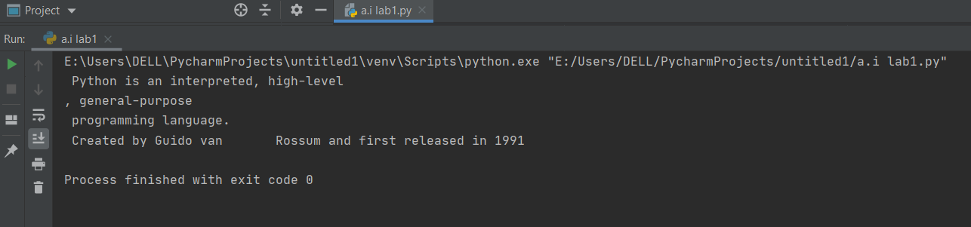

**QNO2:**

Write a program a python program to find the square of any number using

the function:

**Source Code:**

number = float(input(" Please Enter any numeric Value : "))  
  
square = number * number  
  
print("The Square of a Given Number {0}= {1}".format(number, square))

**Output:**

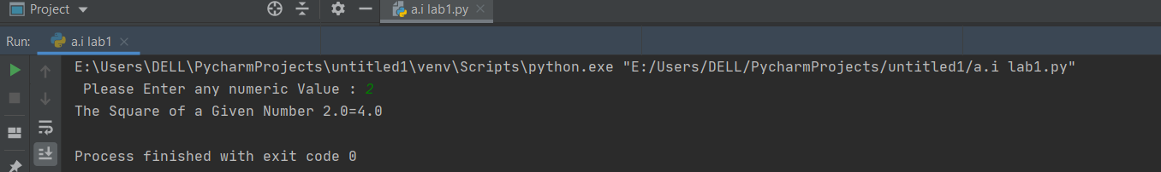

**QNO3:**

Write a Python program to create a tuple and perform following operations :

**Sample** ( 8,9,6, 3.2,1.5,4.4,8)

● get the 4th element and 5 th element

● find the repeated items

● check whether an element(10) exists within a tuple

**Source Code:**

t=( 8,9,6, 3.2,1.5,4.4,8)  
item=t[4]  
print("get item 4:",item)  
item1=t[5]  
print("get an item 5:",item1)  
count=t.count(8)  
print("find the pepeated items:",count)  
print("check whether element (10) exist in a tupple:",10 in t)

Output:

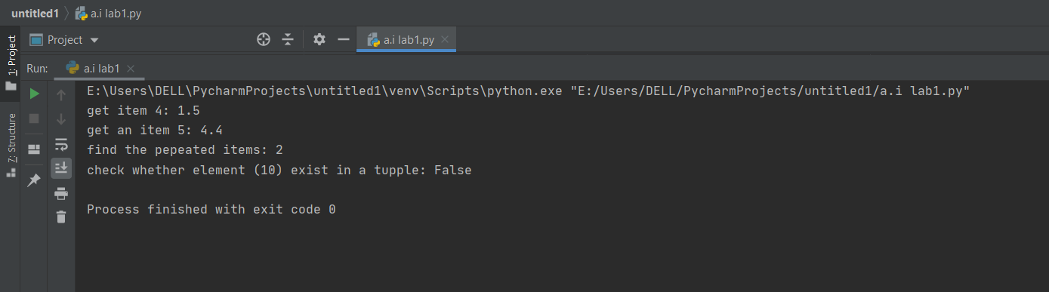

**QNO4:**

Write a python program to perform following operations on a list.

1. Write a Python program to get the largest number from a list

**Source Code:**

l = [10, 20, 4, 45, 99]  
max=max(l) l = [10, 20, 4, 45, 99]  
max=max(l)  
print(max)

Output:

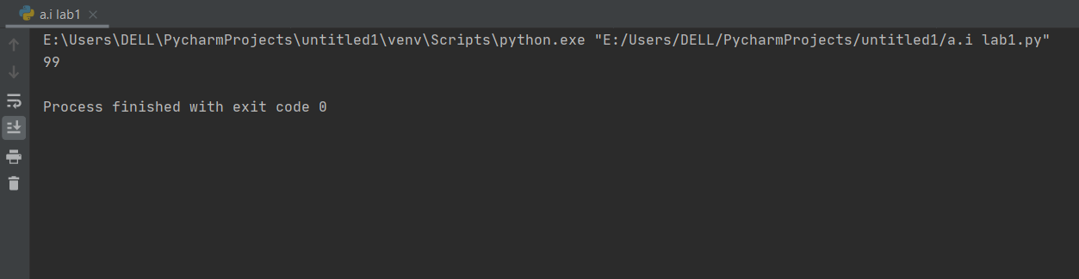

1. Write a Python program to remove duplicates from a list.

**Source Code:**

l=[ 8,9,6, 3.2,1.5,4.4,8]  
d=l.count(8)  
print("there duplicate value:",d)

**Output:**

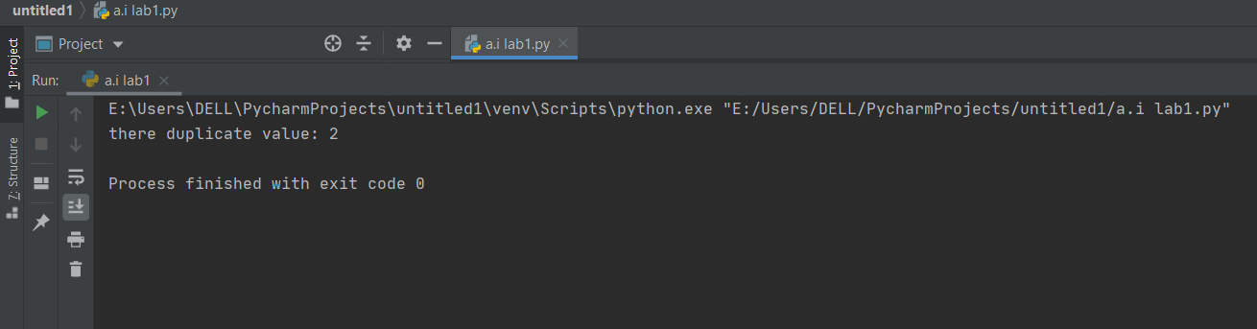

1. Write a Python function that takes two lists and returns True if they have at least one common member

**Source Code:**

def common_data(list1, list2):  
 result = False  
 for x in list1:  
 for y in list2:  
 if x == y:  
 result = True  
 return result  
  
  
print(common_data([1, 2, 3, 4, 5], [5, 6, 7, 8, 9]))  
print(common_data([1, 2, 3, 4, 5], [6, 7, 8, 9]))

**Output:**

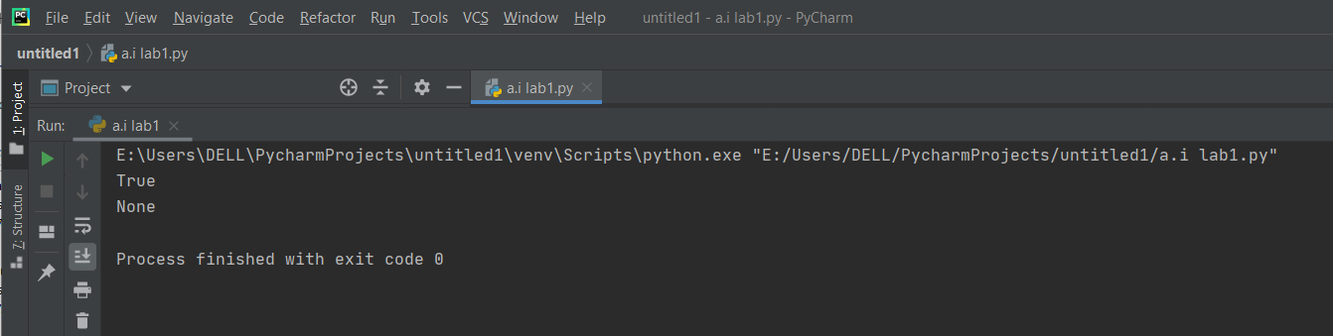

QNO5

Input any string and perform the given operations.

1. Count length of string

**Source code**:

str="hadeer"  
print(len(str))

**Output:**

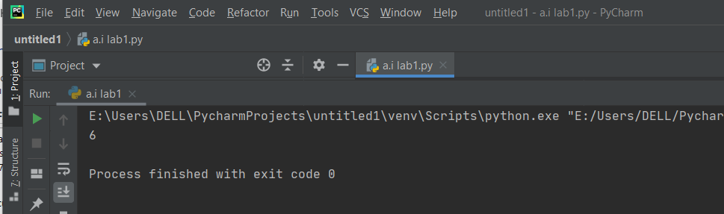

1. Reverse string

**Source Code:**

str = "Hadeer"[::-1]  
print(str)

**Output:**

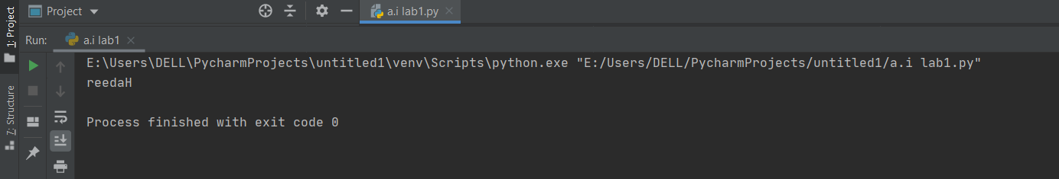

1. Convert in lower case or upper case

**Source Code:**

1. str = "HADEER"  
   print(str.lower())

**Output:**

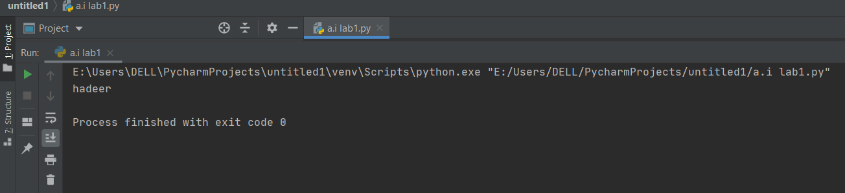

4.Access 1st and last character of string

**Source Code:**

str = "HADEER"  
print(str[0])  
print(str[-1])

**Output:**

